
YEAR 12 CHEMISTRY – ATCHE

Volumetric Analysis Practical Test

Recommended time: 55 minutes

Name: _____________________________________________________
Total marks

/ 40

Teacher: _____________________________________________________

Titration as a Quantitative Chemical Analysis Technique

Determining the composition of a solution is an important analytical and forensic technique.
Sodium carbonate, Na₂CO₃ is an important industrial chemical as it is used in a number of applications including water treatment, general cleaning, descaling and buffer solutions.
Commercial sodium carbonate has a purity of > 98 %. Major impurities in sodium carbonate include sodium chloride. The purity of commercial sodium carbonate depends on the composition of the raw materials, the production process and the intended use of the product.

One common method of measuring the amount of pure sodium carbonate in an impure sodium carbonate mixture is mass percent (or percentage by mass) where

% by mass of Na₂CO₃ = m (pure Na₂CO₃) x 100
m (impure Na₂CO₃ mixture)

The aim of this investigation is to use knowledge of acid-base reactions and titration technique to accurately determine the amount of pure sodium carbonate in a sodium carbonate/sodium chloride (Na₂CO₃/NaCl) mixture and hence calculate the percentage by mass of sodium carbonate in the sample provided.

Procedure:

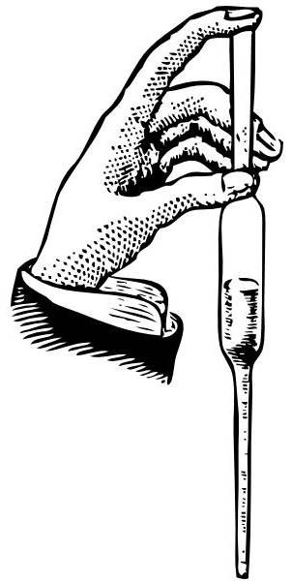
- Use a pipette or buretta to transfer a 20.0 mL aliquot of the sodium carbonate/ sodium chloride solution mixture into ONE of the conical flasks given.


2 During the session your supervisor will come around and observe your technique in using the buretta. Please make sure you have been seen and ask if you have not!
3

3 Titrate the 20.0 ml aliquot of sodium carbonate/sodium chloride solution mixture (conical flask) against the standardised hydrochloric acid solution from the burette by selecting ONE of the two indicators provided.

Put up your hand and ask your supervisor to assess the colour at the end point.
3

4 Repeat Steps 1 and 3 until you obtain consistent results.

Record all your results in the table below and calculate the average titration volume.
3
Burette Reading

Titration | 1 | 2 | 3 | 4
Final Volume (V₂)

Initial Volume (V₁)

Titration Volume (mL)
(ΔV) = V₂ - V₁

2
Average Titration Volume = ________ mL

5 Write a balanced IONIC chemical equation for the titration reaction between HCl and Na₂CO₃ in the
space provided below. Include in your equation the correct states of matter.
2

________________________________________________________________________________________

Additional information from the whiteboard

Concentration of standardised HCl = _____________ mol L⁻¹

Mass of Na₂CO₃/NaCl mixture = _____________ g L⁻¹

6 Calculation:

Use your titration results and additional information from the whiteboard to calculate the percentage by mass of Na₂CO₃ in the Na₂CO₃/NaCl mixture.

% by mass of Na₂CO₃ = m (Na₂CO₃) / m (Na₂CO₃/NaCl) x 100
4
=

Final Answer
_{Accuracy} | ₀ | ₁ | ₂ | ₃

% by mass of Na₂CO₃ to three (3) significant figures = ____________%

Volumetric Analysis – Written Section (20 marks)

Name: _____________________________________________________

Teacher: _____________________________________________________

In each of the following, write the correct name, formula, number or descriptive term that best match the description.

1 | A name given to a solution of exactly known concentration that can be obtained highly pure with a known formula and high molecular mass.
2 | ONE (1) example of a substance that satisfies the conditions listed in Question 1.
3 | A name given to glass equipment used to accurately deliver a fixed volume of solution.
4 | Name of glass equipment that must not be pre-rinsed with the solution to be added to it.
5 | The level of accuracy to which final and initial volumes should be read from the burette. (Plus or minus ? mL)
6 | A name given to the volume difference between the initial volume and the final volume of titration.
7 | Name of a substance that can be added to the reaction mixture in the conical flask without affecting the outcome of the titration.
8 | Give an example of a SYSTEMATIC error that could occur in this experiment.
9 | Write the name of an indicator that would be suitable in the titration between ethanoic acid and sodium hydroxide.
10 | 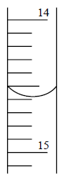  Write the reading (to the correct number of decimal places)  shown on the burette opposite.

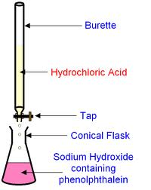
The following questions refers to the following titration:

Ethanoic acid

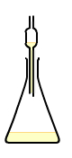

Pipette or
Buretta

For this experiment, state the correct final rinsing solution for each of the following glassware:

11 | Burette
12 | Pipette/Buretta
13 | Conical flask

Questions 15-18 refer to the use of indicators in the titration above.

14 | State the change in the colour of phenolphthalein indicator as the titration proceeds. | From _____ to ______
15 | State the pH range of the reaction mixture at the equivalence point.
16 | State the change in indicator colour if methyl orange was used instead of phenolphthalein. | From _____ to ______
17 | State the pH at the end point of methyl orange indicator.

State the effect of the following acts on the volume of ethanoic acid used to achieve the equivalence point in the titration above. Write your answer as more acid is used, less acid is used or no effect.

18 | Distilled water was used as the final rinse for the burette.
19 | Sodium hydroxide was used as the final rinse for the conical flask.
20 | Methyl orange was used as the indicator.

